Specified requirement

1. Do not Solder

Do not solder the **red pad** in the figure below.

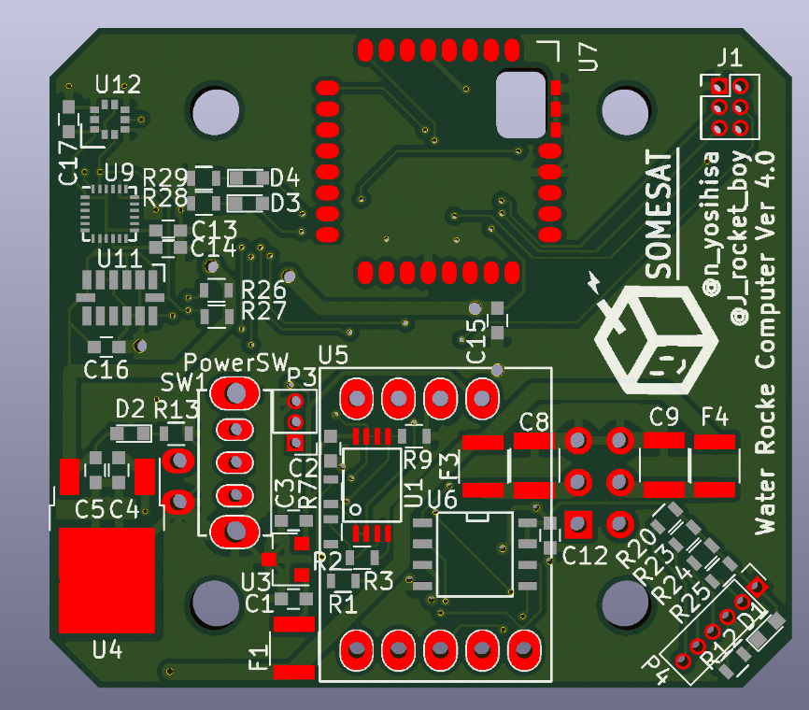

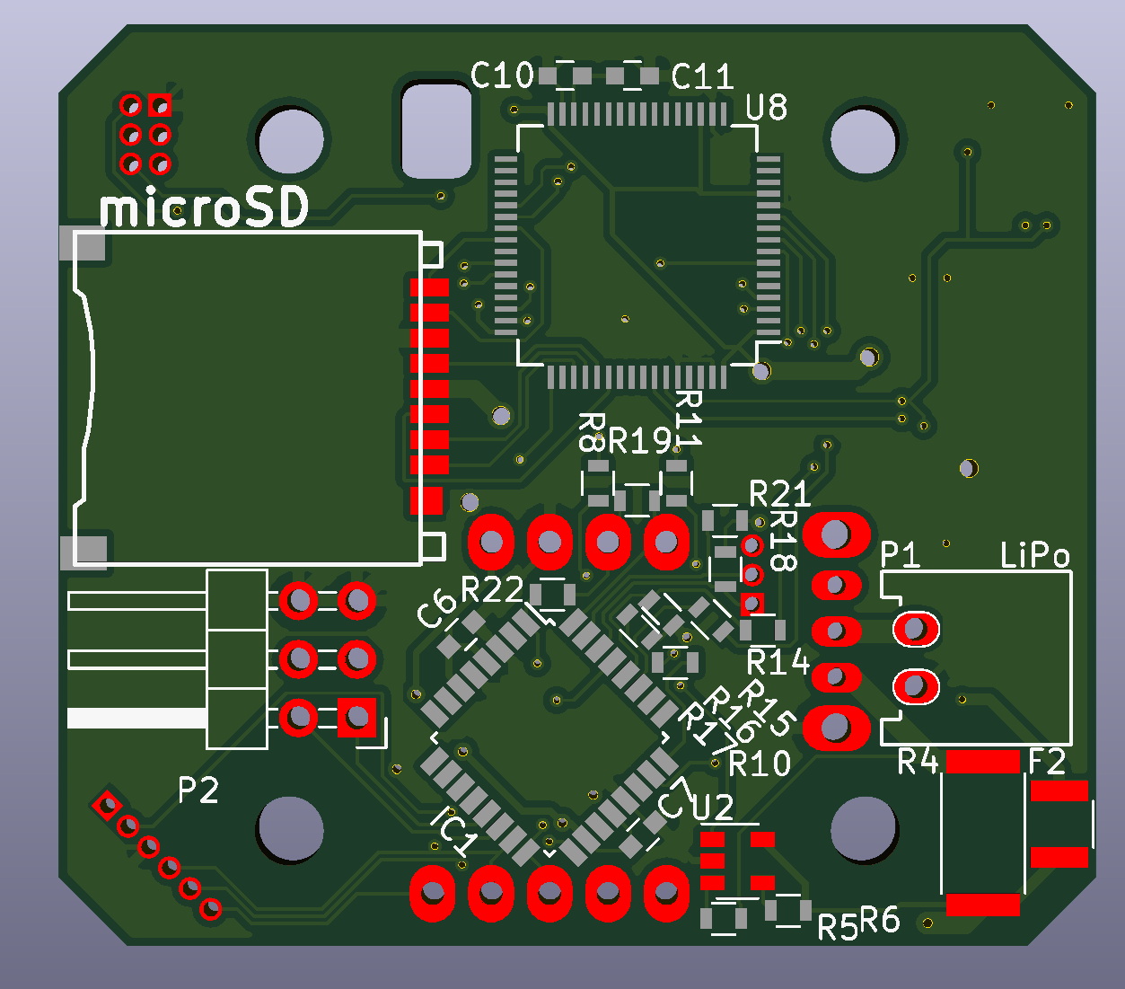

1. About IC pin mapping

IC's pin assigned as the following. **Green pad** is 1pin.

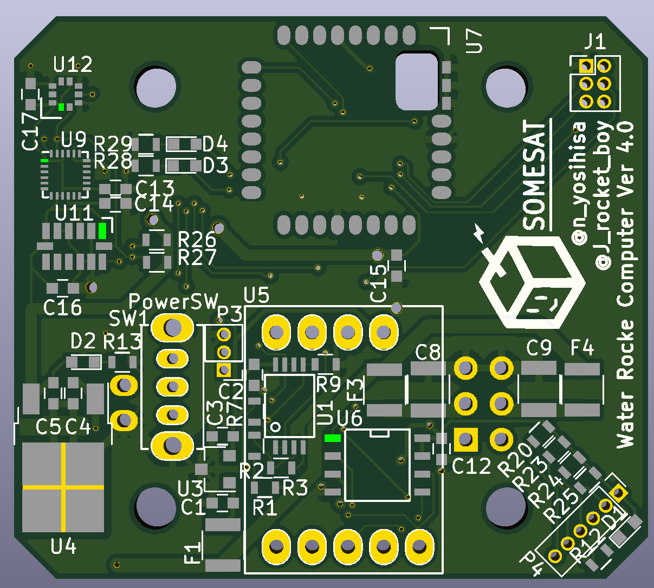

1

4

8

5

U6

7

14

8 13

6 1

U11

18

13

1

6

24 19

7 12

U9

8

10

5

3

7 6

U12

1 2

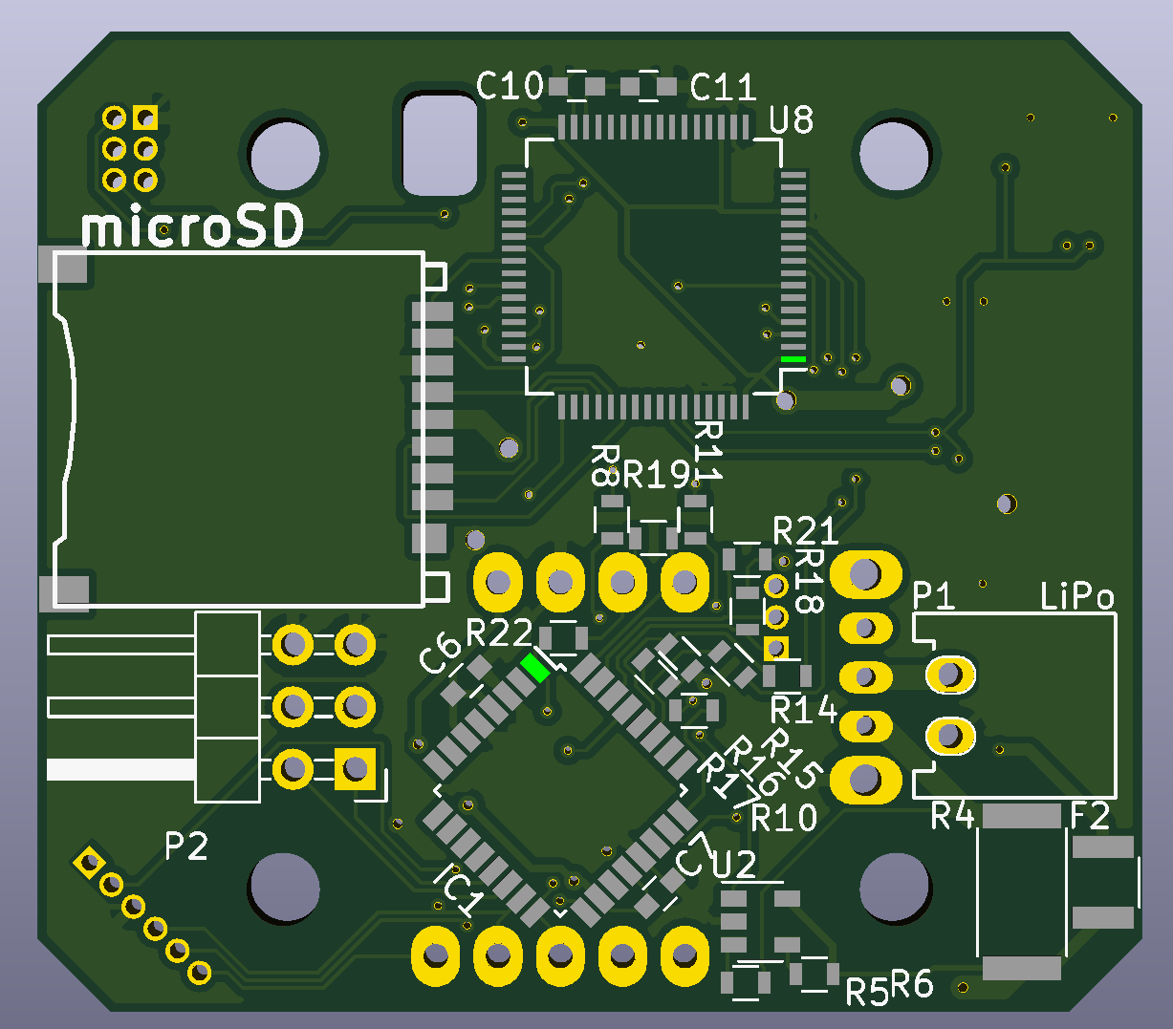

32 25

9 16

1

8

24

17

IC1

U8

32 17

49 64

33

48

16

1

1. 3D image.

